1. Generate excel Addin boilerplate using Office Yeoman generator. Select Office Add-in Task pane project type

1. Open the project in visual studio code .

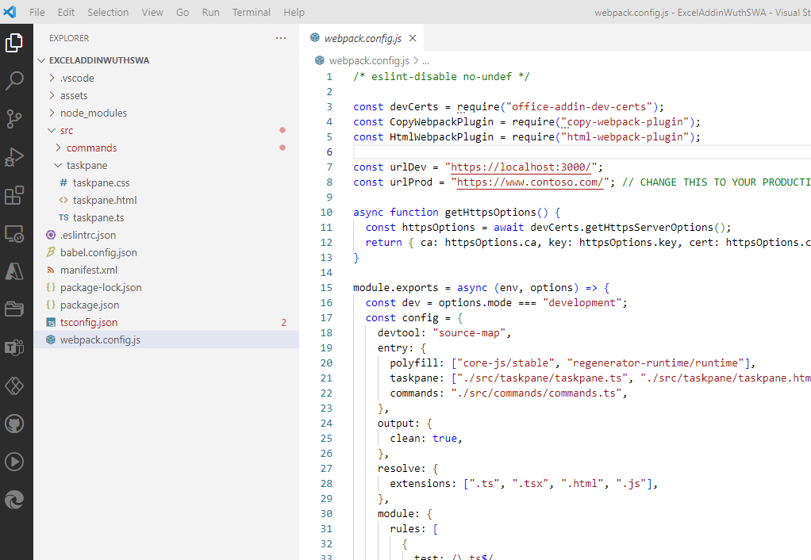

1. Initialize the git hub repo using the source control pluggin in visual studio code.

1. Once the repo is initialized in Github, commit and push the code to the repo.
2. Install Azure Static Web App extension for Visual studio code.

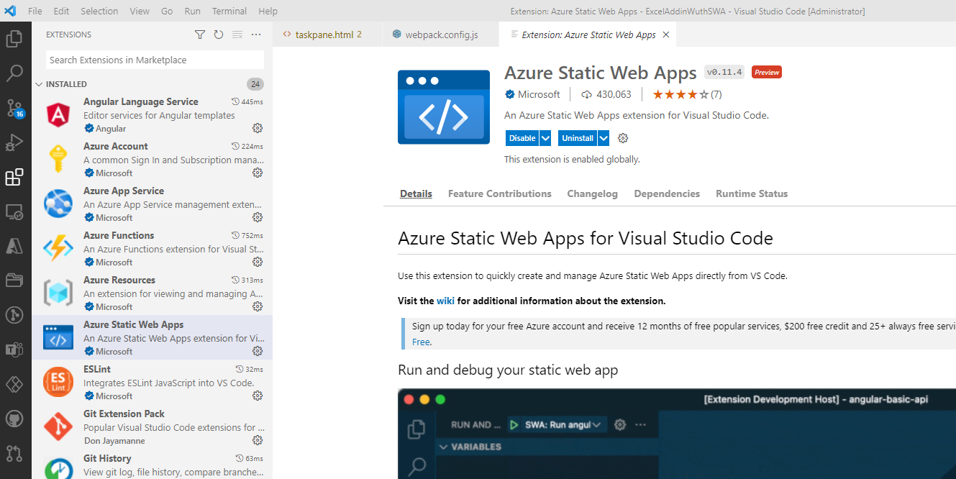

1. Sign into your Azure tenant using the Azure SWA extension.
2. Open the extension and under the node for your subscription, create a new static web app.

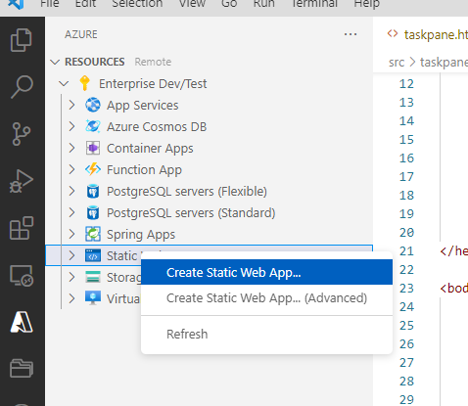

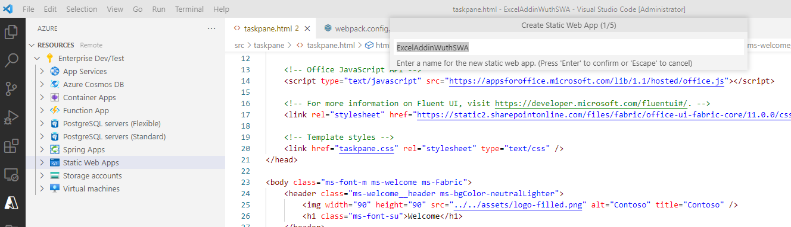

Keep all other options as default.

1. This will add github action workflow file in your excel addin project.

1. Go to the dist folder created by build command . Create a copy of taskpane.html and rename it to index.html. This needs to be done each time you run npm build
2. Go to the azure extension and select the new static web app created. Right and click Browse site.

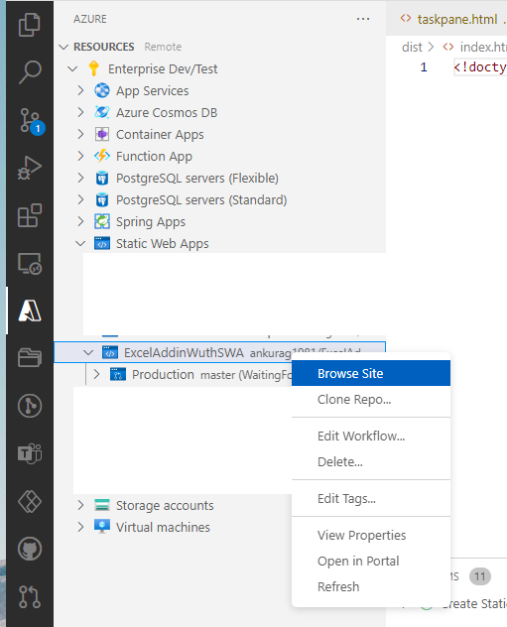

Copy the site url .

1. Open manifest.xml in src folder and add the copied link in appdomain.

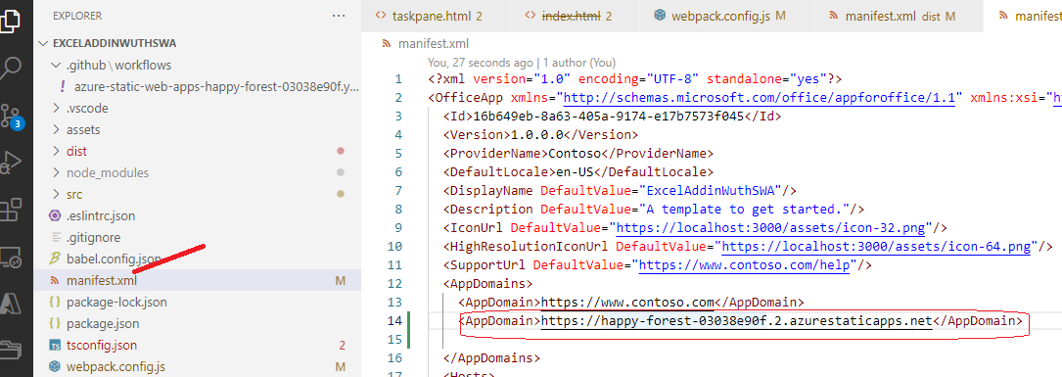

1. Go to the webpack.config.js. Replace the urlprod value from [www.contoso.com](http://www.contoso.com) to the SWA link you have copied.

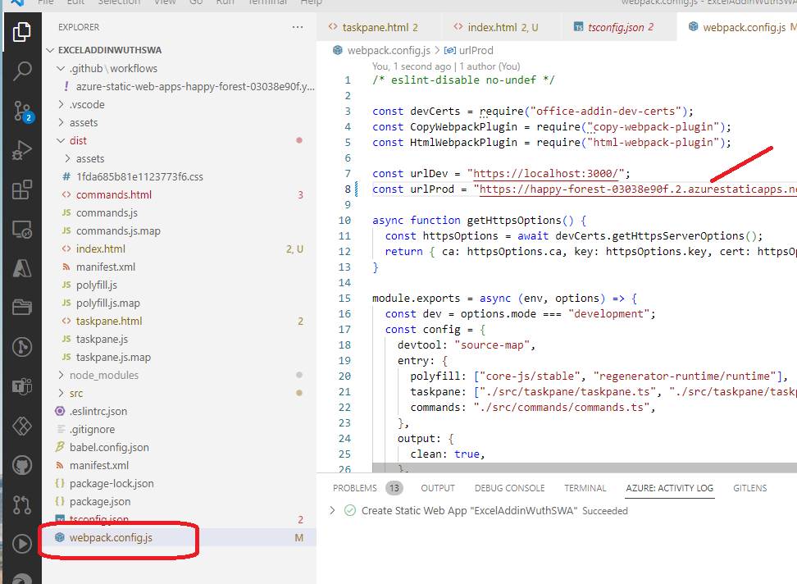

Run command – npm run build

This should generate the manifest in dist folder with new SWA link.

1. Goto the github folder and open github actions YAML file. Make the changes as shown below

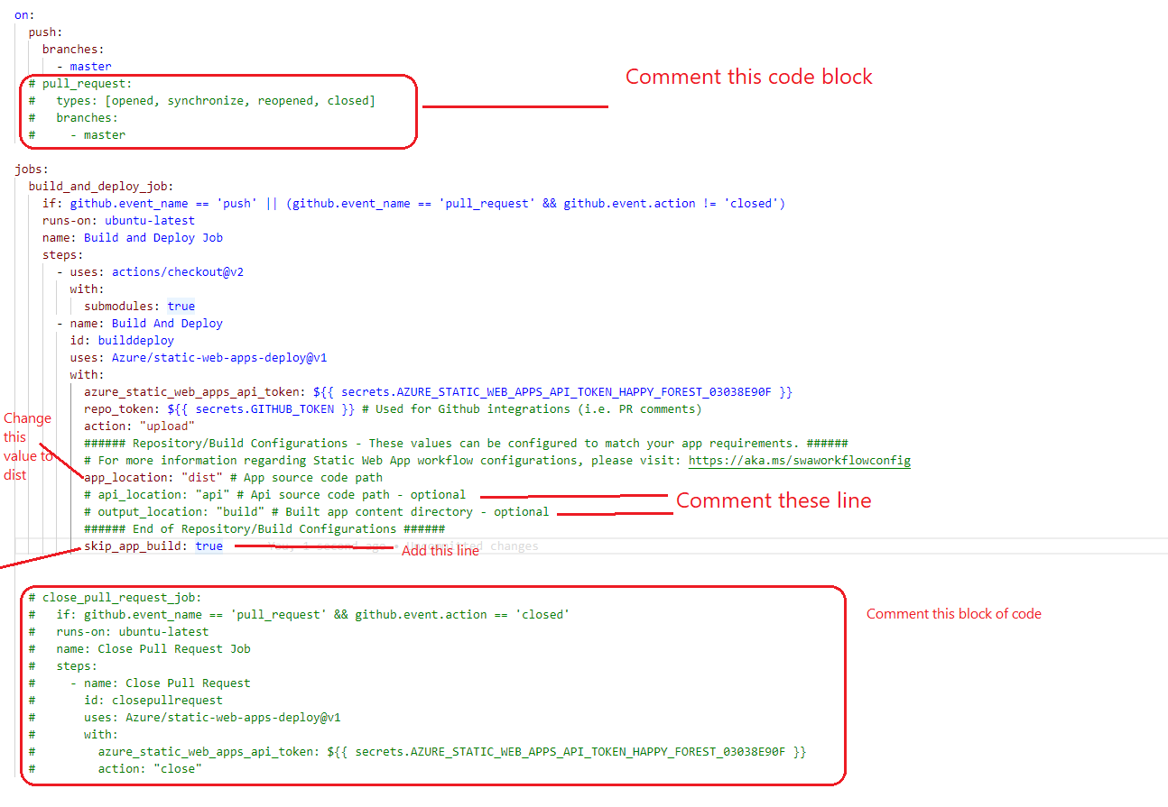

1. Run npm build . Make sure to copy taskpan.html and rename it as index.html.
2. Commit and push the code to github. Once done go to actions in Github repo . You should see the action competed successfully.

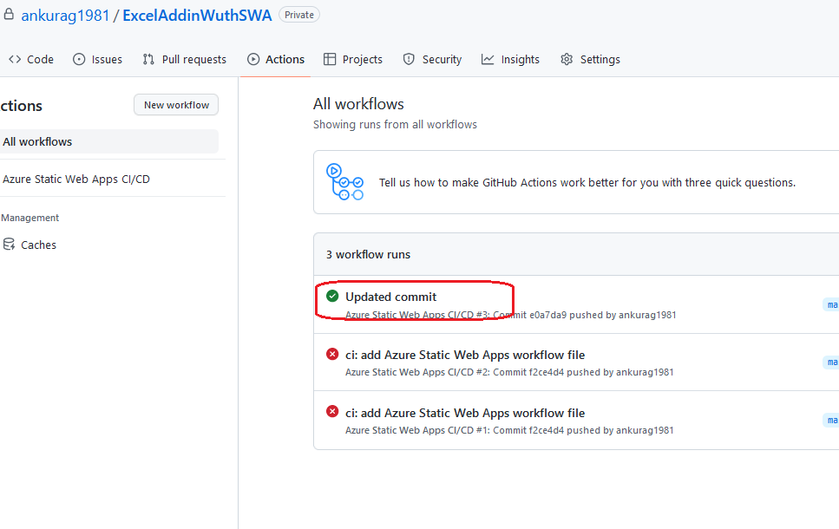

You should be able to see the sample Addin app when you browse to your AZURE SWA

Side load your addin using manifest from dist folder . you should see the addin successfully loaded inexcel.

